ST. XAVIER’S COLLEGE

**Maitighar, Kathmandu**



**Computer Graphics**

**Lab Assignment #1**

**SUBMITTED BY:**

**Rojesh Tamrakar**

**013BSCCSIT032**

**SUBMITTED TO**

|  |  |
| --- | --- |
| **Er. Anil Sah**  **( Lecturer )** |  |
| **Department of Computer Science** | |

Submission Date: August 4th 2015

**OBJECTIVE 1.1: TO BUILD A SIMPLE CALCULATOR**

**Source Code:**

#include "Unit1.h"

//---------------------------------------------------------------------------

#pragma resource "*.dfm"

TForm1 *Form1;

int x, y, z;

int flag=0, oper;

//---------------------------------------------------------------------------

__fastcall TForm1::TForm1(TComponent* Owner)

: TForm(Owner)

{

}

int setvalue(int a)

{

if(flag==0)

{

x=a;

flag=1;

return x;

}

else

{

y=a;

flag==0;

return y;

}

}

//---------------------------------------------------------------------------

void __fastcall TForm1::Button1Click(TObject *Sender)

{

Edit1->Text=setvalue(1);

}

//---------------------------------------------------------------------------

void __fastcall TForm1::Button12Click(TObject *Sender)

{

oper=3;

}

//---------------------------------------------------------------------------

void __fastcall TForm1::Button6Click(TObject *Sender)

{

Edit1->Text=setvalue(6);

}

//---------------------------------------------------------------------------

void __fastcall TForm1::Button5Click(TObject *Sender)

{

Edit1->Text=setvalue(5);

}

//---------------------------------------------------------------------------

void __fastcall TForm1::Button2Click(TObject *Sender)

{

Edit1->Text=setvalue(2);

}

//---------------------------------------------------------------------------

void __fastcall TForm1::Button3Click(TObject *Sender)

{

Edit1->Text=setvalue(3);

}

//---------------------------------------------------------------------------

void __fastcall TForm1::Button4Click(TObject *Sender)

{

Edit1->Text=setvalue(4);

}

//---------------------------------------------------------------------------

void __fastcall TForm1::Button7Click(TObject *Sender)

{

Edit1->Text=setvalue(7);

}

//---------------------------------------------------------------------------

void __fastcall TForm1::Button8Click(TObject *Sender)

{

Edit1->Text=setvalue(8);

}

//---------------------------------------------------------------------------

void __fastcall TForm1::Button9Click(TObject *Sender)

{

Edit1->Text=setvalue(9);

}

//---------------------------------------------------------------------------

void __fastcall TForm1::Button13Click(TObject *Sender)

{

Edit1->Text=setvalue(0);

}

//---------------------------------------------------------------------------

void __fastcall TForm1::Button15Click(TObject *Sender)

{

switch(oper)

{

case 1:

z=x+y;

break;

case 2:

z=x-y;

break;

case 3:

z=x*y;

break;

case 4:

z=x/y;

break;

}

Edit1->Text=z;

}

//---------------------------------------------------------------------------

void __fastcall TForm1::Button10Click(TObject *Sender)

{

oper=1;

}

//---------------------------------------------------------------------------

void __fastcall TForm1::Button11Click(TObject *Sender)

{

oper=2;

}

//---------------------------------------------------------------------------

void __fastcall TForm1::Button14Click(TObject *Sender)

{

oper=4;

}

//---------------------------------------------------------------------------

void __fastcall TForm1::Button16Click(TObject *Sender)

{

Edit1->Text=0;

}

//---------------------------------------------------------------------------

void __fastcall TForm1::Button17Click(TObject *Sender)

{

Edit1->Text=" ";

}

//---------------------------------------------------------------------------

**OUTPUT:**

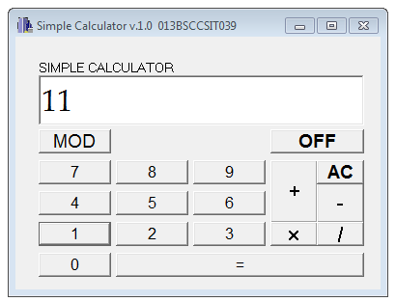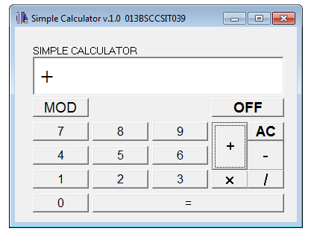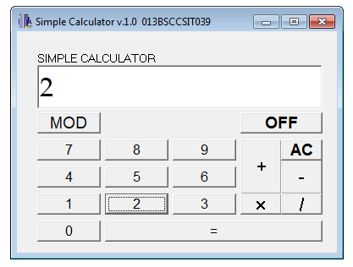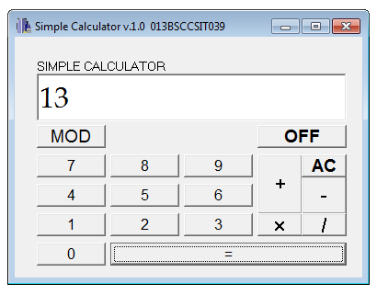

Fig: Addition Operation in Simple Calculator

**CONCLUSION:**

The program could perform simple integer calculation problems such as addition, subtraction, multiplication, division and finding modulus. This is a simple integer calculator thereby unable to handle decimal calculations.

**OBJECTIVE 1.2: TO MAKE A CHECKERED BOX**

**Source Code:**

#include <vcl\vcl.h>

#pragma hdrstop

#include "Unit1.h"

//---------------------------------------------------------------------------

#pragma resource "*.dfm"

TForm1 *Form1;

//---------------------------------------------------------------------------

__fastcall TForm1::TForm1(TComponent* Owner)

: TForm(Owner)

{

// to draw rectangle

Image1->Canvas->Pen->Width=3;

Image1->Canvas->Brush->Color=clRed;

Image1->Canvas->Rectangle(10,10,210,210);

// to draw line

Image1->Canvas->MoveTo(10,10);

Image1->Canvas->LineTo(210,210);

Image1->Canvas->MoveTo(210,10);

Image1->Canvas->LineTo(10,210);

Image1->Canvas->MoveTo(10,110);

Image1->Canvas->LineTo(210,110);

Image1->Canvas->MoveTo(110,10);

Image1->Canvas->LineTo(110,210);

Image1->Canvas->MoveTo(10,110);

Image1->Canvas->LineTo(210,110);

Image1->Canvas->MoveTo(10,60);

Image1->Canvas->LineTo(210,60);

Image1->Canvas->MoveTo(10,160);

Image1->Canvas->LineTo(210,160);

Image1->Canvas->MoveTo(60,10);

Image1->Canvas->LineTo(60,210);

Image1->Canvas->MoveTo(160,10);

Image1->Canvas->LineTo(160,210);

}

//-------------------------------------------------------------------------

OUTPUT:

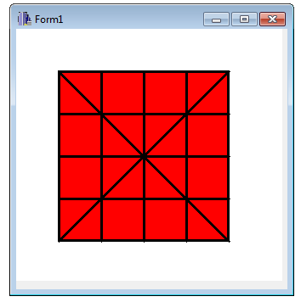

Fig: A checkered box

**CONCLUSION:**

It is possible to make a checkered box using the Rectangle, MoveTo, LineTo and other associated graphical functions in C++ Builder.